

**STANDARD OPERATING PROCEDURE**

**Do not Photocopy**

**Document Information Classification: Unrestricted**

|  |  |
| --- | --- |
| **Title:** | **TRE Capacity Management** |
| **Effective Date:** | **14 Feb 2019** |
| **Reference Number:** | **SOP-09-05** |
| **Version Number:** | **1.1** |
| **Owner:** | **TRE Infrastructure and Security Management Process Owner,** |
| **Review Date:** | **26 Nov 2020** |

Table of Contents

1. Purpose 3

2. Scope 3

3. Responsibilities 3

4. Procedure 3

4.1. Thresholds 3

4.2. Current utilisation and performance statistics 3

4.3. Querying metrics with Ansible 4

5. Cross-referenced ISMS Documents 4

6. Appendices 4

1. Purpose

The use of resources should be monitored, tuned and projections made of future capacity requirements to ensure the required system performance. This document defines the [process to ensure that information is gathered about the use of TRE infrastructure that can be used to support the decisions to ensure sufficient capacity is available for current and future projects.

1. Scope

TRE infrastructure components including: CPU, memory, storage, network, power and cooling.

1. Responsibilities

The System Administrators are responsible for:

* reporting resource allocation thresholds, current utilisation and performance bottlenecks.

The Information Security Manager (ISM) is responsible for:

* reviewing the allocation thresholds, current utilisation and performance statistics
* recommending changes required to ensure the efficient and effective operation of the TRE.

1. Procedure
   1. Thresholds

TRE System Administrators will record component thresholds in the Infrastructure Record. This will be reviewed and updated at least every three months.

* 1. Current utilisation and performance statistics

System Administrators will:

* Ensure Sysstat packages and utilities are installed;
* Perform sampling and analysis of performance metrics;
* Report performance statistics;

Reports will be produced at least every three months. Power and cooling will not be monitored as there is excess capacity, but will be reviewed as part of the infrastructure change control process.

System utilisation monitoring software will record statistics over a per month rotation cycle, comprehensive performance metrics will be logged via the sys-stat package and utilities.

**iostat**: Reports all statistics about your CPU and I/O statistics for I/O devices.

**mpstat**: Details about CPUs (individual or combined).

**pidstat**: Statistics about running processes/task, CPU, memory.

**sar**: Save and report details about different resources (CPU, Memory, IO, Network, kernel etc..).

**sadc**: System activity data collector, used for collecting data in backend for sar.

**sa1**: Fetch and store binary data in sadc data file. This is used with sadc.

**sa2**: Summaries daily report to be used with sar.

**Sadf**: Used for displaying data generated by sar in different formats (CSV or XML).

Example usage - sar commands:

$ sar -A # view all metric for current day

$ sar -r 3 10 # view memory utilisation

$ sar -dp # view disk stats

Time specific queries – on the 22nd at 14:20 to 15:00 report system activity:

$ sar -f /var/log/sa/sa22 -s 14:20:00 -e 15:00:00 -w -q -i 4

Performance data for 1 month is retained in this location:

/var/log/sa/{sa01 – sa31}

Sysstat utilities support outputs in scalable vector graphics which will produce chart formats.

$ sadf -g /var/log/sa/sa22 [ -- sar_options ] > output-22nd.svg

*sample output in appendices*

* 1. Querying metrics with Ansible

Ansible commands will be used to return values for CPU, memory and disk space utilisation for individual instances or all TRE projects defined under the Ansible tre-guests alias group.

From the Ansible management host:

$ ansible tre-guests -m shell -a 'lscpu|grep CPU\(s\)\:'

$ ansible tre-guests -m shell -a ‘free -m’

$ ansible tre-guests -m shell -a ‘mpstat’

$ ansible tre-guests -m shell -a ‘sar -r’

$ ansible tre-guests -m shell -a 'df -h /home ; df -h /'

1. Cross-referenced ISMS Documents

|  |  |  |
| --- | --- | --- |
| Number | Type | Title |
| <NO DATA> | <NO DATA> | <NO DATA> |

1. Appendices

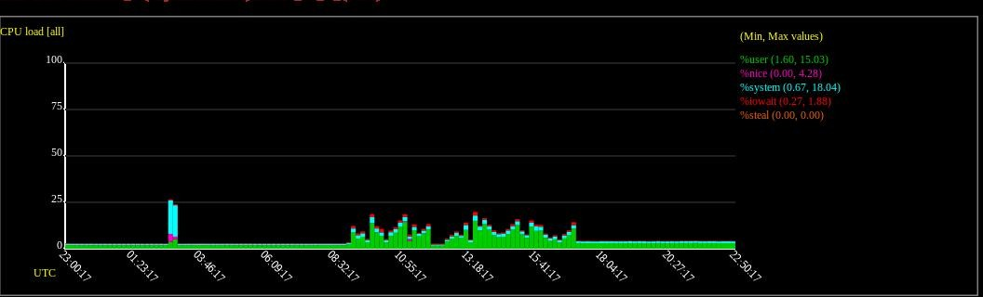

Figure 1: Sysstat scalable vector graphics output.